1.1 Data and preprocessing
- Species:
1. Oryza sativa ssp. japonica (IRGSP-1.0)
2. Oryza brachyantha (O. brachyantha v1.4b)
- Data sources
1. Whole-genome DNA FASTA for both species from Ensembl Plants (release 41).
2. TE annotations in GFF3 format from the APTE database:
- japonica_TE.gff3
- brachyantha_TE.gff3
3. Gene annotations in GFF3 format from Ensembl Plants:
- Oryza_sativa.IRGSP-1.0.41.gff3
- Oryza_brachyantha.Oryza_brachyantha.v1.4b.41.gff3
4. A rice expression matrix expression_japonica.txt (MSU LOC_Os IDs; used later for planned TE–expression analysis but not yet integrated).
- Preprocessing in R
1. Loaded TE GFF3 files with base R (read.table).
2. Filtered to TE features and computed TE length as end - start + 1.
3. Parsed the type field into Class / Order / Family, storing them as ClassLevel, OrderLevel, FamilyLevel.
4. Removed entries with missing or invalid coordinates.
1.2 TE composition and genome coverage
Method
- Summarised TE base pairs per Order (LTR, TIR, Helitron, MITE, LINE, SINE, etc.) for each species.
- Computed the fraction of total TE bases contributed by each order.
- Computed total genome size from FASTA by summing sequence line lengths.
- Calculated TE genome coverage:
$$\text{TE\% genome}=\frac{∑\text{TE length}}{\text{genome}\text{ size}}×100$$
Results:
- TE % genome
1. O. sativa japonica: 93.5% of the genome masked by TEs
2. O. brachyantha: 54.8% of the genome masked by TEs
- TE composition by order:
1. LTR retrotransposons are the dominant component, especially in japonica (much higher fraction than in brachyantha).
2. TIR DNA transposons contribute a substantial and comparable fraction in both genomes, slightly higher in brachyantha.
3. Helitrons are much more abundant in brachyantha than in japonica.
4. MITE, LINE and SINE elements contribute smaller but detectable fractions in both species.
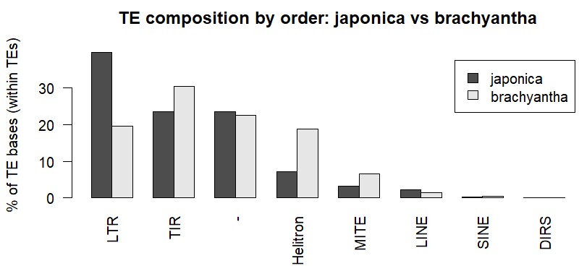
1.3 TE density along the genome
Method
- For each species, we split each chromosome into 1 Mb windows.
- For each window, we computed TE base coverage by intersecting TE intervals with the window and summing overlap.
- Calculated window TE density = TE bp / window size.
- Plotted TE density along the length of chromosome 1 for both species.
Key observations
- Japonica chromosome 1 shows high and variable TE density, with clear peaks (likely pericentromeric regions) where TE density exceeds 1 (due to overlapping elements).
- Brachyantha chromosome 1 shows lower overall TE density and a smoother profile, with a modest central peak but less extreme variation.
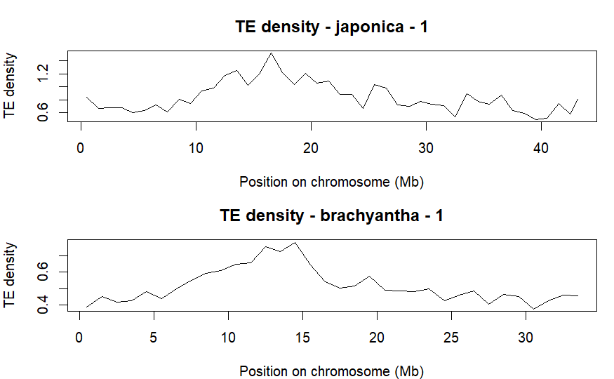
1.4 From TE fragments to TE insertions
Method
- APTE GFF3 is fragment-level (partial LTRs, internal regions, nested fragments).
- Implemented a custom R function collapse_TE_insertions() that:
1. Sorts TEs by chromosome and start coordinate.
2. Merges overlapping or very close fragments (gap ≤ 50 bp) into a single TE insertion interval.
Results
- Estimated TE insertion counts:
1. japonica: 210,619 TE insertions
2. brachyantha: 198,249 TE insertions
This gives a more realistic picture of copy number, not just fragment count.
1.5 TE–gene distance
Method
- Loaded gene GFF3 for both species and kept only type == "gene" entries.
- For each TE insertion, computed the distance to the nearest gene on the same chromosome:
  - Used gene midpoints and TE midpoints with findInterval for efficiency.
- Produced histograms of TE–gene distances for japonica and brachyantha.
Key observations
- In both genomes, most TEs are located very close to genes (large spike at small distances).
- Japonica has a heavier tail: many TEs lie far from the nearest gene, consistent with its very TE-rich, expanded genome.
- Brachyantha TE–gene distances are generally shorter, reflecting a more compact genome with genes more tightly packed relative to TEs.
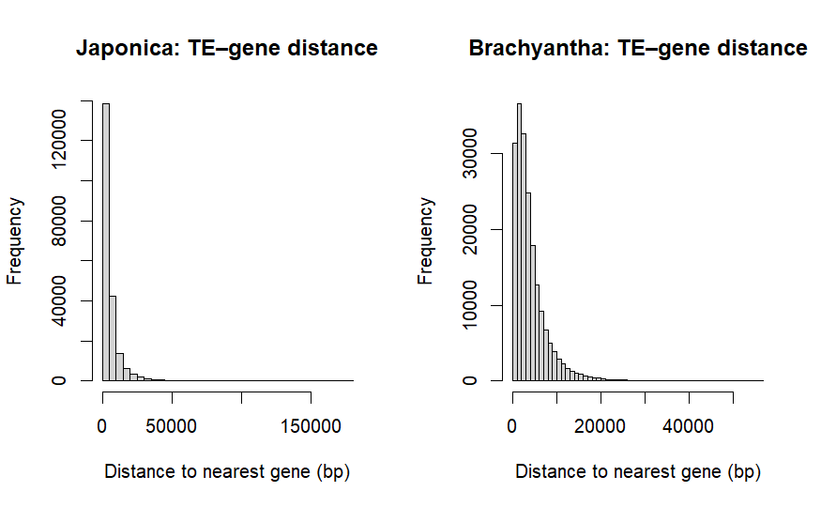

1.6 What is not done yet
- TE–expression correlation:
  - Expression file uses MSU LOC_Os IDs with transcript versions (LOC_Os05g28440.1).
  - Gene GFF3 uses RAP/Ensembl IDs (gene:Os01g0100100).
  - Direct merging failed (0 matches).
  - Needs an ID mapping table (MSU ↔ RAP) or an ID-conversion R package.
- Promoter-focused analysis (e.g. TE count within 2 kb upstream of genes) not yet implemented.
2. How to add the missing TE–expression step
To finish the TE–expression part, we need to map MSU expression IDs to RAP IDs used in jap_genes.
2.1 The plan to continue (if I have time);
- Download a RAP–MSU ID mapping table (e.g. “RiceID table”) from a rice genomics resource.
- Put it in your expression/ folder, e.g. RiceIDtable.csv.
- Clean and standardise:
  - Expression IDs → MSU IDs without version (LOC_Os05g28440, not .1).
  - GFF gene IDs → RAP IDs without the gene: prefix (Os01g0100100).
- Merge expression → mapping table → GFF to link expression values with TE distances.
- Compute TE–expression correlation.

TE Analysis Type | Tree Fern | What we did
TE annotation | de novo | used APTE (not de novo)
TE genome coverage | yes | yes
TE class/order composition | yes | yes
TE family expansion | yes | yes
TE density genome-wide | yes | yes (simplified)
TE fragment collapsing → insertions | yes(with full distinction) | yes
LTR insertion age (time since insertion) | yes | no
Solo-LTR / intact-LTR ratio | yes | no
TE size contribution by family | yes | (partially)
TE effect on genome structure | yes | no
TE–gene distances | yes | yes
TE–gene expression correlation | yes | no (pending expression + ID mapping)

